Project 1.5: Drawing a Face

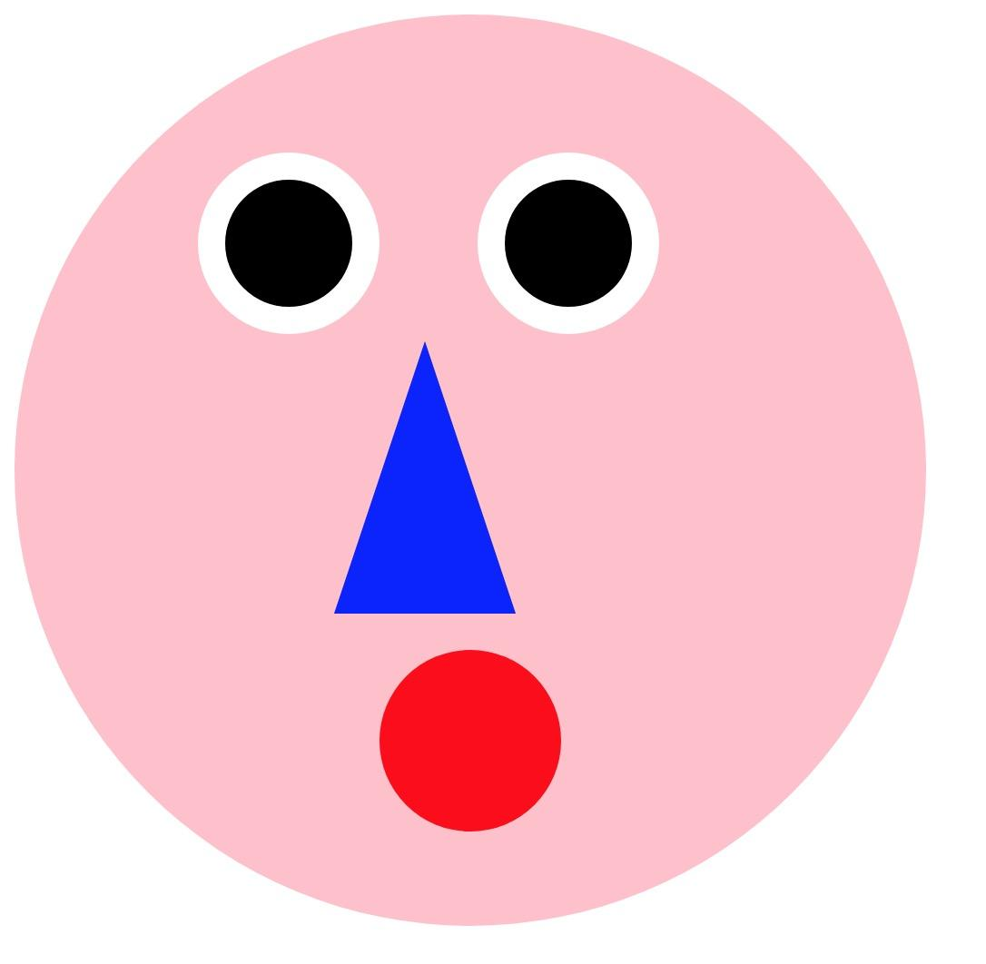

After learning id/class selector, box-model, and basic css layout, we’re ready to make some css drawing! This assignment is intended to help you get familiar with how to space and position elements with box-model and display:inline-block;.

Please follow the instructions to 1) style the provided divs to circles or triangles. 2) using box-model and css layout to position the shapes. 3) Play with it: change the colors, shapes, and add interactive features.

**Instruction:**

**Stage 1: style the provided divs to circles or triangles.**

1. In your class folder, create a local file project1-5.html on your laptop. Open [this source](https://weiwanghasbeenused.github.io/CreativeComputing2019FA_K/examples/proj1-5.txt) code and copy-paste everything to your project1-5.html.
2. Create another file project1-5.css, and link it to project1-5.html by adding path to the <link> element in project1-5.html.
3. In project1-5.css, select **#face**, and give it these properties:

**width:500px;**

**height:500px;**

**border-radius:50%;**

**background-color: pink;**

1. **border-radius:50%;** is the key to drawing a circle (more css shapes [here](https://css-tricks.com/the-shapes-of-css/)).Open the html with your browser, check if #face is styled as a big, pink circle with a 500px diameter.
2. Make **.eye** a **white** circle, with a **100px** diameter.

Make **.pupil** a **black** circle, with a **50px** diameter.

Make **#mouth** a **red** circle, with a **100px** diameter.

Make **#nose** a **blue** pointing-up triangle, with a **50px** diameter. (this [link](https://css-tricks.com/the-shapes-of-css/) again. Find out how to draw triangle in it!)

1. Check the browser again, you should see something like this.

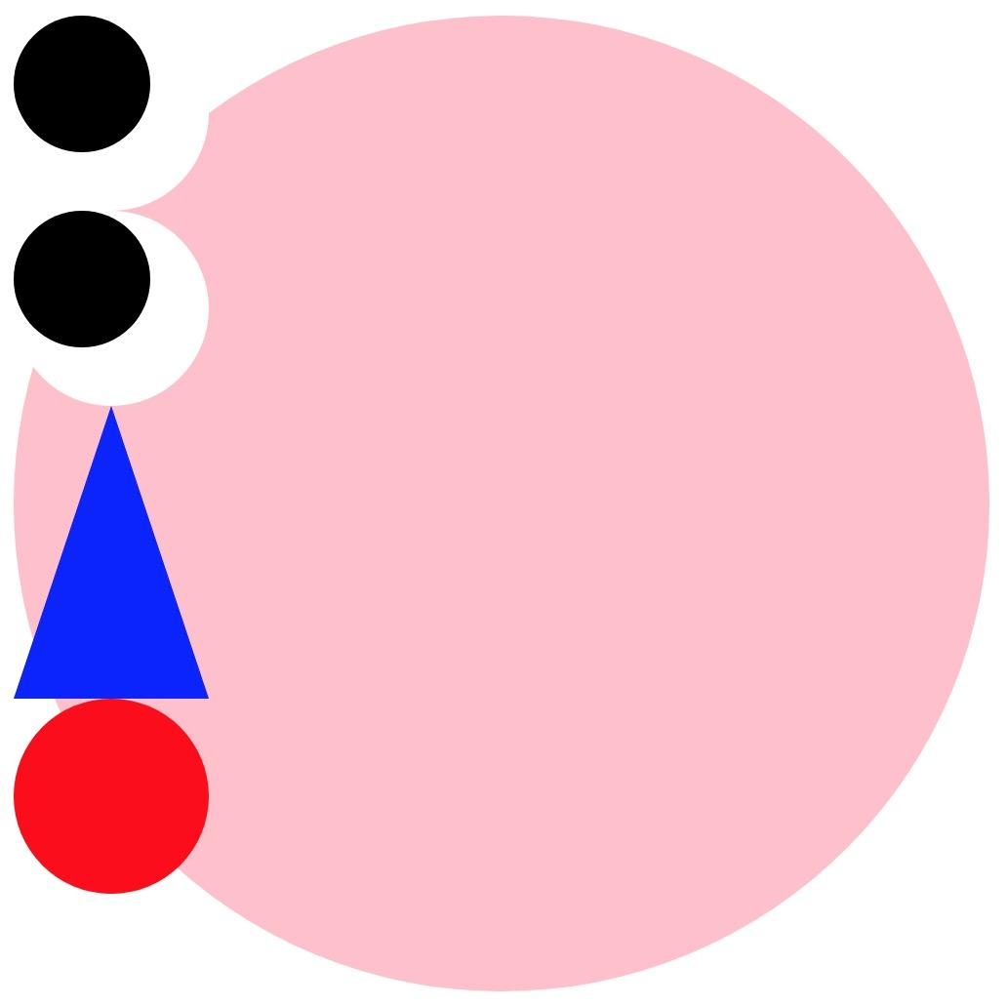

If not, please make sure:

You’re using the right selector in css (.class #id)

You have assigned a background-color to these elements.

**Stage 2: using box-model and css layout to position the shapes.**

1. Use **display:inline-block** to make the eyes on the same row.
2. Use **margin** to position the elements on the face.



**Stage 3: Play with it**

1. Change shapes: although we’re not able to fully understand how the shapes are drawn, we can still try to change the values, and see how the shape distorted. Play with it!
2. Add shapes: the provided shapes are the minimal requirement for this assignment. Feel free to add more.
3. Change colors
4. Interactive features: use [hover selector](https://www.w3schools.com/cssref/sel_hover.asp) to give the face some interactive behaviors. After adding hover, take a look at [transition](https://www.w3schools.com/css/css3_transitions.asp).